**Work Study**

#### Definition of Work Study:

***“Work study is a generic term for those techniques, particularly method study and work measurement, which are used in all its context and which lead systematically to the investigation of all the factors, which effect the efficiency and economy of the situation being reviewed in order to effect improvement.”***

The main objective of work study is to improve productivity of men, machines and materials. The aim of work study is to determine the best method of performing each operation and to eliminate wastage so that production increases with less fatigue. The work study is also used in determining the standard time that a qualified worker should take to perform the operation when working at a normal place.

#### Objectives of Work Study:

**The following are the objectives of work study:**

1. Increased efficiency,

2. Better product quality,

3. To choose the fastest method to do a job,

4. To improve the working process,

5. Less fatigue to operators and workers,

6. Effective labour control,

7. Effective utilisation of resources,

8. To decide equipment requirements,

9. To pay fair wages,

10. To aid in calculating exact delivery,

11. To formulate realistic labour budgeting, and

12. To decide the required manpower to do a job.

***Steps of Work Study***

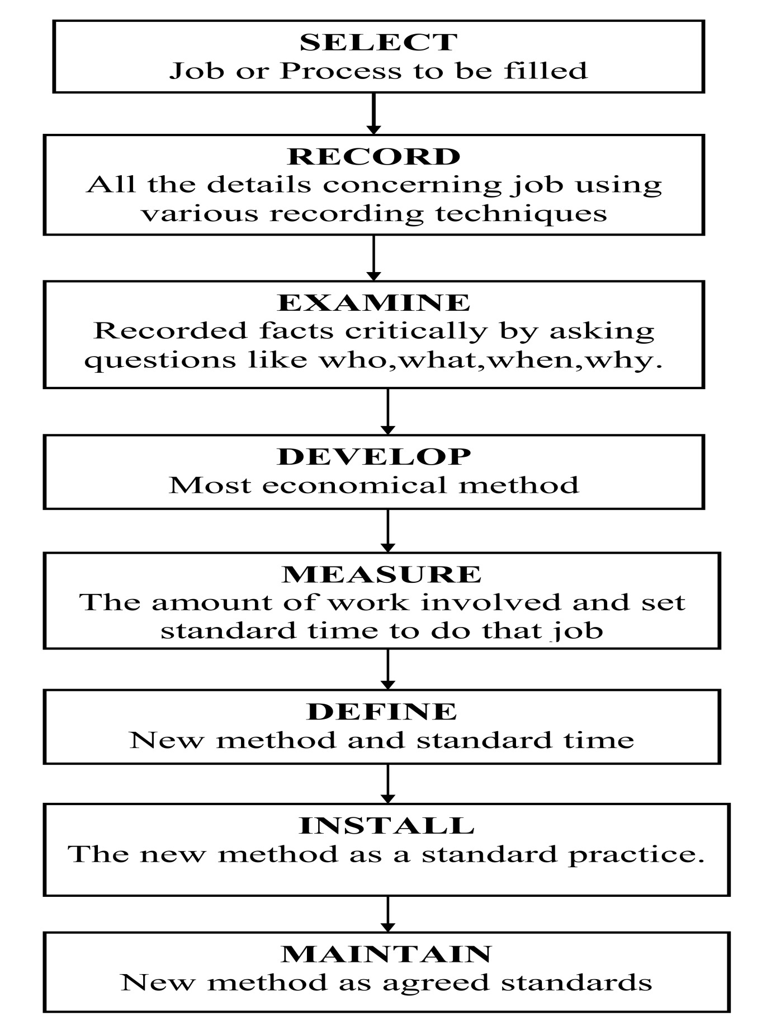

#### Steps Involved in Work Study:

**The steps of work study are:**

(i) It selects the jobs which are to be studied;

(ii) It examines critically the recorded facts which are already done;

(iii) It records from direct observations all the matters which are happened;

(iv) It defines new method;

(v) It also installs the new method;

(vi) It also maintains the new standard;

### ****Definition and Concept of Method Study:****

Method study is basically conducted to simplify the work or working methods and must go towards higher productivity. It is always desirable to perform the requisite functions with desired goal and with minimum consumption of resources. Method signifies how a work is to be done i.e. description of how we consume resources in order to achieve our target?

**Method Study may be defined as:**

***“A procedure for examining the various activities associated with the problem which ensures a systematic, objective and critical evaluation of the existing factors and in addition an imaginative approach while developing improvements.”***

***There are three aspects of its application:***

1. Method study proper is concerned with broad investigation and improvement of a shop/section, the layout of equipment and machines and the movement of men and materials.

(2) Motion study is a more detailed investigation of the individual worker/operator, layout of his machines tools, jigs and fixtures and movement of his limbs when he performs his job. The ergonomics aspect i.e. studies of environment, body postures, noise level and surroundings temperature also form part of investigation

(3) Micro motion study i.e., much more detailed investigation of very rapid movements of the various limbs of the worker.

**Objectives of Method Study!**

Always, the objective of method study is to simplify the job and develop more economical methods of doing it. Method study is systematic both in investigation of problem being considered and in the development of its solutions. It can be stated as one of most penetrating tools of investigation available to management.

**Important objectives of method study are:**

(1) The improvement of processes and procedures.

(2) Factory and work place layout improvement.

(3) Improvement in the design of plant and equipment.

(4) Reduction in unnecessary fatigue and movements.

(5) Use of improved materials, machines and manpower.

(6) Better Working conditions.

**Steps or Procedure Involved in Methods Study**

The basic approach to method study consists of the following eight steps. The detailed procedure for conducting the method study is shown in the following figure.

1. ***SELECT***the work to be studied and define its boundaries.
2. ***RECORD***the relevant facts about the job by direct observation and collect such additional data as may be needed from appropriate sources.
3. ***EXAMINE***the way the job is being performed and challenge its purpose, place sequence and method of performance.

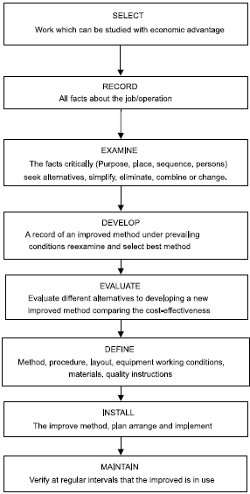

***Method study procedure***

1. ***DEVELOP***the most practical, economic and effective method, drawing on the contributions of those concerned.
2. ***EVALUATE***different alternatives to developing a new improved method comparing the cost- effectiveness of the selected new method with the current method with the current method of performance.
3. ***DEFINE***the new method, as a result, in a clear manner and present it to those concerned, *i.e*., management, supervisors and workers.
4. ***INSTALL***the new method as a standard practice and train the persons involved in applying it.
5. ***MAINTAIN***the new method and introduce control procedures to prevent a drifting back to the previous method of work.

**Work Measurement**

Work measurement is concerned with the determination of the amount of time required to perform a unit of work. Work measurement is very important for promoting productivity of an organization. Work measurement provides basis for proper planning. Since it is concerned with the measurement of time it is also called ‘Time Study’.

Work measurement has been defined by British Standard Institution as, **“The application of techniques designed to establish the time for a qualified worker to carry out a specified job at a defined level of performance”**. This time is called standard or allowed time. Time study may also be defined as **“the art of observing and recording the time required to do each detailed element of an industrial operation”**.

There are various ways in which work may be measured and a variety of techniques have been established. The basic procedure, irrespective of the particular measurement technique being used, consists of three stages ;

* **analysis** phase in which the job is divided into convenient, discrete components, commonly known as elements;
* **measurement** phase in which the specific measurement technique is used to establish the time required (by a qualified worker working at a defined level of performance) to complete each element of work;
* **synthesis** phase in which the various elemental times are added, together with appropriate allowances (see below), to construct the standard time for the complete job.

#### Objectives of Work Measurement:

1. To compare the times of performance by alternative methods.

2. To enable realistic schedule of work to be prepared.

3. To arrive at a realistic and fair incentive scheme.

4. To  aid in preparing budgets.

5. To determine standard costs.

6. To assist in the organisation of labour by daily comparing the actual time with that of target time.

**Techniques of Work Measurement**

For the purpose of work measurement, work can be regarded as:

1. **Repetitive work:** The type of work in which the main operation or group of operations repeat continuously during the time spent at the job. These apply to work cycles of extremely short duration.
2. **Non-repetitive work:** It includes some type of maintenance and construction work, where the work cycle itself is hardly ever repeated identically.

***Various techniques of work measurement are:***

1. Time study (stop watch technique),
2. Synthesis,
3. Work sampling,
4. Predetermined motion and time study,
5. Analytical estimating.

Generally, the following procedure is followed in conducting stop watch time study:

1. Selection of task to be timed: Select the task or job that needs to be timed for study purpose. There are various priorities on the basis of which task or job to be studied is selected such as bottleneck or repetitive jobs, jobs with longer cycle time, to check correctness of existing time, comparison of two methods etc.

2. Standardize the Method of Working: To achieve performance standard accuracy it is necessary to record the correct method of working.

3. Select the operator for study: Select the consistent worker whose performance should be average or close to average so that observed times are close to normal times.

4. Record the details: The following information is recorded on observation sheet: Name of labour, task/job performed, department, section of work activity, general information about activity performed etc.

5. Break the task into element: Each operation is divided into a number of elements. This is done for easy observation and accurate measurement.

6. Determine number of cycles to be measured: It is important to determine and measure the number of cycles that needs to be observed to arrive at accurate average time. A guide for the number of cycles to be timed based on total number of minutes per cycle.

7. Measure the time of each element using stop watch: The time taken for each element is measured using a stop watch. There are two methods of measuring. viz., Fly back method and Cumulative method. The time measured from the stop watch is known as observed time.

8. Determine standard rating: Rating is the measure of efficiency of a worker. The operator„s rating is found out by comparing his speed of work with standard performance. The rating of an operator is decided by the work study man in consultation with the supervisor. Various rating methods used are speed rating, synthetic rating and objective rating.

9. Calculate the Normal time: The observed time cannot be the actual time required to perform the work for a worker. Therefore, Normal time needs to be calculated. Normal time is the time that a worker takes when working at normal pace. It is calculated as below: Normal Time = Observed time * Rating

10. Determine the allowance: A worker cannot work all the day continuously. He will require time for rest going for toilet, drinking water etc. Unavoidable delays may occur because of 106 tool breakage etc. So some extra time is added to the normal time. The extra time is known as allowance. It is generally allotted as per the company policy.

11. Determine the standard time: The standard time is the sum of Normal time and allowances. Thus it is calculated as below: Standard Time = Normal Time + Allowances

Work Sampling

Work-sampling is defined as a technique for determining and predicting the total or the proportion of the time consumed by a specified activity. It is dependent upon the observations that have been made over a while to record the [frequency](https://www.marketing91.com/frequency-marketing/) of the [events](https://www.marketing91.com/event-marketing-brand-equity/) that are being performed and the happenings in that instant.

Work-sampling is a statistical concept which permits recognition, analysis and enhancement of job responsibilities, organisational workflows, [performance](https://www.marketing91.com/performance-based-marketing/) competencies and tasks.

An essential use of the work-sampling method is predicting the standard time for a manufacturing task conducted manually. It is used in several processes like [telemarketing](https://www.marketing91.com/telemarketing/), manufacturing and [customer service](https://www.marketing91.com/5-steps-to-setup-better-customer-service-process/).

The general characteristics of work-sampling method are as follows-

* It requires sufficient time to complete the **study**
* It is feasible for the work-sampling method to study multiple workers at a time instead of one single worker or a small group
* The cycle time of work-sampling is generally lengthy
* The work cycle is non-repetitive

## **Applications**

The applications of work-sampling process are as follows-

* Work-sampling enables a fair share of job [distribution](https://www.marketing91.com/distribution-definition/) amongst the workforce
* It is applied to find an estimate about delay times that are unavoidable for deciding about the delay allowances
* The data that is available from the work-sampling method has proved a great help in the process of production [planning](https://www.marketing91.com/importance-of-planning/)
* A work-sampling method is a helpful tool for the administration as it helps in evaluating the [efficiency](https://www.marketing91.com/efficiency-effectiveness/) levels of the various departments in the organization
* The work-sampling assist the management in an organization to find all the data and information of idle time and its cause
* Work sampling can be applied for the utilization of cranes, machine tools, trucks, etc
* It is used to get an estimate of the percentage of time consumed by various job activities like inspection, repair, and supervision
* Work sampling is a useful tool that is applicable in finding time standards for repair work, office work, maintenance work, etc

## Labor Selection Process

Every organisation creates a selection process because they have their own requirements. Although, the main steps remain the same. So, let’s understand in brief how the selection process works.

# Selection Process

### ****Preliminary Interview****

This is a very general and [basic interview](https://www.toppr.com/bytes/soft-skills-internship-placement/) conducted so as to eliminate the candidates who are completely unfit to work in the organisation. This leaves the organisation with a pool of potentially fit employees to fill their vacancies.

### ****Receiving Applications****

Potential employees apply for a job by sending applications to the organisation. The application gives the interviewers information about the candidates like their [bio-data](https://www.toppr.com/guides/business-correspondence-and-reporting/resume-writing/), work experience, hobbies and interests.

### ****Screening Applications****

Once the applications are received, they are screened by a special screening committee who choose candidates from the applications to call for an interview. Applicants may be selected on special criteria like qualifications, work experience etc.

### ****Employment Tests****

Before an organisation decides a suitable job for any individual, they have to gauge their talents and skills. This is done through various [employment tests](https://www.toppr.com/guides/business-management-and-entrepreneurship/human-resource-management/performance-appraisal/) like intelligence tests, [aptitude tests](https://www.toppr.com/guides/reasoning-ability/coding-decoding/coding-decoding-practice-questions/), proficiency tests, personality tests etc.

### ****Employment Interview****

The next step in the selection process is the employee interview. Employment interviews are done to identify a candidate’s skill set and ability to work in an organisation in detail. Purpose of an employment interview is to find out the suitability of the candidate and to give him an idea about the work profile and what is expected of the potential employee. An employment interview is critical for the selection of the right people for the right jobs.

### ****Checking References****

The person who gives the reference of a potential employee is also a very important source of information. The referee can provide info about the person’s capabilities, experience in the previous companies and [leadership](https://www.toppr.com/guides/business-studies/directing/leadership/) and [managerial skills.](https://www.toppr.com/guides/business-management-and-entrepreneurship/nature-of-management-and-its-process/management-functions/) The information provided by the referee is meant to kept confidential with the [HR department](https://www.toppr.com/guides/business-management-and-entrepreneurship/human-resource-management/).

### ****Medical Examination****

The medical exam is also a very important step in the selection process. Medical exams help the employers know if any of the potential candidates are physically and mentally fit to perform their duties in their jobs. A good system of medical checkups ensures that the employee standards of health are higher and there are fewer[cases of absenteeism](https://www.toppr.com/bytes/absenteeism/), accidents and employee turnover.

### ****Final Selection and Appointment Letter****

This is the final step in the selection process. After the candidate has successfully passed all written tests, interviews and medical examination, the employee is sent or emailed an appointment letter, confirming his selection to the job. The [appointment letter](https://www.toppr.com/guides/business-communication-and-ethics/business-correspondence/parts-of-business-letter/) contains all the details of the job like working hours, salary, leave allowance etc. Often, employees are hired on a conditional basis where they are hired permanently after the employees are satisfied with their performance.

### ****Importance of the Selection Process****

1. Proper selection and placement of employees lead to growth and development of the company. The company can similarly, only be as good as the capabilities of its employees.
2. The hiring of talented and skilled employees results in the swift achievement of company goals.
3. Industrial accidents will drastically reduce in numbers when the right technical staff is employed for the right jobs.
4. When people get jobs they are good at, it creates a sense of satisfaction with them and thus their work efficiency and quality improves.
5. People who are satisfied with their jobs often tend to have high morale and [motivation to perform better](https://www.toppr.com/guides/business-management-and-entrepreneurship/direction-and-coordination/elements-of-direction-motivation/).

# Wage Payment

### Definition of Wages

Wage is termed as a compensation that is given on the basis of the amount of work done and the hours spent in doing that. Wages are variable and do vary with day to day functioning of an individual. Wages are given to labours who are engaged in manufacturing processes and get the compensation on a daily basis.

Labour is paid on the basis of hours and in order to increase the pay, extra hours have to be devoted to fetch more.An individual is paid for his presence, not for his absence i.e. in case a person do not come for the work he will not be paid for that day.

The waged person are said to be doing “**blue collar labour job”** which implies that an individual is engaged in the unskilled or semi-skilled job and is drawing wages on a daily basis.

# Difference Between Salary and Wages

The term salary and wages is often confused by people and is used interchangeably. But the truth is that both these terms differ from each other and hold different meanings. **Salary** is a fixed amount paid or transferred to the employees at regular intervals for their performance and productivity, at the end of the month whereas **wages** are hourly or daily-based payment given to the labour for the amount of work finished in a day.

The main difference between salary and wages lies in the fact that salary is fixed, i.e. it is predetermined and agreed between the employer and employee, while wages are not fixed, as it varies depending on the performance of the labour. This article presents you the important differences between salary and wages in tabular form.

### Comparison Chart

| **BASIS FOR COMPARISON** | **SALARY** | **WAGE** |
| --- | --- | --- |
| Meaning | A fixed pay that an individual draws for the work done by him on an annual basis. | A variable pay that an individual draws on the basis of hours spent in completing the certain amount of work. |
| Skills | Skilled personnel | Semi-skilled or unskilled |
| Type of cost | Fixed | Variable |
| Rate of payment | Fixed rate | Wage rate |
| Payment cycle | Monthly | Daily |
| Basis of payment | Performance basis | Hourly basis |
| Paid to whom | Employees | Labor |
| Nature of work | Administrative-office work | Manufacturing-process work |
| KRA (Key resultant area) | Yes | No |
| Extra pay for extra hours | No | Yes |

# Top 3 Methods of Wage Payment

The following points highlight the top three methods of wage payments. The methods are: 1. Time Rate System 2. Piece Rate System 3. Incentive Wage System.

#### Method # 1. Time Rate System:

Under this method of wage payment, the workers are paid the wages on the basis of time. In this system of wage payment, the workers are paid the wages on the basis of time as, per hour, per day, per week, per fortnight or per month etc. This system does not consider the production of the employees during this time.

**The amount of wages under this system is calculated as under:**

Wages = Time spent by the worker × Rate of wages according to time.

**Suitability of Time Rate System:**

**This system of Wage Payment is particularly suitable in the following circumstances:**

1. When it is not possible to measure the production in terms of units or in any other terms.

2. When the work is of high standard.

3. When it is not possible to divide the production into units.

4. When the production is of the nature that it requires efficiency more than the speed.

5. When the worker is undertraining.

**Merits of Time Rate System:**

**1. Simplicity:**

It is very easy to calculate the amount of wage under this system.

**2. Certainty of the Amount of the Remuneration:**

This system of wage payment provides certainty of the amount of wage payment to the employee. It develops the feeling of confidence and certainty among them.

**3. High Quality of Production:**

As this system of wage payment has no concern with quantity of production, quality of production produced by the workers under this system is very high.

**4. Proper Utilisation of the Factors of Production:**

As this system is not related with speed, the workers perform their work in very confident manner. They make the best Utilisation of the factors of production.

**5. Co-Operation between Labour and Capital:**

This system of wage payment brings the industrial peace because it satisfies the workers and the industrialists. Thus, it develops harmony and co­operation between labour and capital.

**6. Best System for Artistic Work:**

This system of wage payment is most suitable for artistic work.

**7. Co-Operation and Unity of Workers:**

As all the employees doing the work for same nature get the same amount of wages, this system develops the feeling of co-operation and unity among the workers.

**8. Suitable for the Health of Workers:**

This system of wage payment is suitable from the point of view of health of workers.

**Demerits of Time Rate System:**

**1. Need of Intensive Supervision:**

This system requires intensive supervision over workers. It increases the cost of supervision.

**2. Lack of Incentive:**

This system of wage payment makes equal payment to both the efficient and inefficient workers. Therefore, efficient workers do not get any incentive for more production.

**3. Encouragement of Labour Unions:**

This system encourages labour unions. Sometimes, these labour unions misuse their powers.

**4. Misuse of Time by Workers:**

Under this system of wage payment, the workers do not make proper Utilisation by their time.

**5. Fall in the Quantity of Production:**

Under this system of wage payment, the quantity of production decreases because the workers do not get any incentive for increasing the production.

**6. High Cost of Production:**

As the production is low and the payment to the worker is more, this system increases the cost of production.

**7. It Kills the Efficiency of Workers:**

As this system does not make any difference between efficient and inefficient workers, it kills the efficiency of efficient workers.

**8. Increase in Cost Per Unit:**

This system increases the cost per unit of production. Under this system, the cost per unit of production is uncertain because the quantity of production differs from time to time.

**9. Difficult to Measure the Efficiency:**

Under this system of wage payment, it is very difficult to measure the efficiency of workers because all the workers of equal status are paid the wages at equal rate.

#### Method # 2. Piece Rate System:

Under this system of wage payment, the workers are paid the wages on the basis of quantity and quality of work performed by them. Under this system, the rates of wages are determined according to quantity and quality of work and the workers are paid according to these rates.

**The amount of wages to be paid to a worker under this system is calculated as under:**

Wages = Units of production × Rate per unit.

**Suitability of Piece Rate System:**

**This system of wage payment is very suitable in the following conditions:**

1. When the work is of standard nature.

2. When the work can be measured easily.

3. When there is a great need of increase in the production.

**Merits of Piece Rate System:**

**1. Incentive to More Work:**

This system encourages the workers to do more and more work because they get their wages according to their work.

**2. Proper Utilisation of Machines:**

Under this system, the workers use their machines and equipment with proper care because they feel that if their machine is out of order, their work will be held up and their wages will be low.

**3. Increase in the Quantity of Production:**

The system of wage payment gets more production because all the workers make their best efforts to increase the production.

**4. Best Utilisation of Time:**

As the workers are paid according to their work, they make the best possible utilisation of their time. They do not want to waste their time.

**5. Decrease in the Cost of Production:**

This system decreases the cost of production because the maximum production is done by the workers in the minimum time. It decreases the cost per unit of production also.

**6. Decrease in the Cost of Supervision and Administration:**

This system of wage payment minimises the needs of supervision. It reduces the cost of supervision.

**7. Easy and Simple:**

This system of wage payment is very easy to understand and very simple to calculate.

**8. Improvement in the Standard of Living of Workers:**

Workers get more wages because they produce more. It increases their efficiency and productivity. It increases their remuneration also which improves their standard of living.

**9. Mobility of Workers:**

This system of wage payment increases the mobility of workers because they can change their enterprise easily.

**10. Measurement of the Efficiency of the Workers:**

This system provides an opportunity to measure the efficiency of the workers. It makes proper distinction between efficient and inefficient working staff of the enterprise.

**11. Justified:**

This system of wage payment justified also because the workers are paid the wages according to the work performed by them.

**12. Helpful in Maintaining Industrial Peace:**

This system brings industrial peace also because it satisfies both the workers and the employer.

**Demerits of Piece Rate System:**

**1. Lack of Unity among Workers:**

This system lacks the unity and mutual co-operation among workers. They feel themselves competitor to each other.

**2. Loss of Workers on the Failure of Machines etc.:**

It because of any reason, the machines fail or the power fails, the work of workers is held up and they lose their wages.

**3. Misuse of the Factors of Production:**

The workers do not pay proper attention towards the factors of production. They only want to increase the speed of production.

**4. Adverse Effect on the Health of Workers:**

This system motivates the workers to do more and more work. It affects the health of workers adversely.

**5. Low Quality of Production:**

This system of wage payment does not pay any attention on the quality of production. As a result of it the quality of production falls down.

**6. Unsuitable for Artistic Work:**

This system is not suitable for artistic work because artistic work cannot be paid only on the basis of quantity of production.

**7. Uncertainty of Wages:**

As the amount of wages depends upon the quantity of production, the actual amount of wages to be paid is always uncertain. The workers also cannot estimate their remuneration in advance.

#### Method # 3. Incentive Wage System:

There are two basic systems of wage payment—time rate system and piece rate system. Both the systems have their merits and demerits. No system can be considered suitable for all times and under all circumstances. To maintain the merits of both the systems and to overcome the demerits of these systems, some experts have developed the systems of incentives wage.

These systems are also known as incentive wage systems, progressive wage system and bonus schemes etc. Under these systems, both the time and speed are considered as the basis of wage payment.

These systems provide incentives to the workers to produce more and more maintaining the quality as well. The workers are paid bonus or premium for the additional work. It is important to note that almost all the systems incentive wages provide for minimum guaranteed wages to the workers.

**Characteristics of an Ideal Incentive Wage System:**

1. It must be easy to calculate and to understand.

2. The standards of work must be determined on scientific basis.

3. It must establish direct relationship between efforts and remuneration.

4. It must give a guarantee of minimum wage to all the workers.

5. It must be in the interests of both the employers and the employees.

6. It must be flexible but stable.

7. It must be framed in the manner so that it may be used widely for all the activities of the enterprise.

8. It must be helpful in increasing the production as well as productivity.

**Advantages of Incentive Wage System:**

i. There is increase in the prospect of workers to earn more. As shown by F. Herzberg good salary is one of the hygiene factors in the absence of which people are unhappy and dissatisfied. Wage incentive offers them the prospect of earning more.

ii. The scientific work study which is done before introducing a wage incentive plan brings about improvements in methods, work­flow, and man-machine relationship and so on.

iii. There is effective reduction in the supervision costs Closer supervision of employees becomes unnecessary because workers become more responsible. Rather than the supervisor chasing the workers the workers themselves sometimes chase the supervisor for materials, tools, etc.

iv. Employees promptly expose all such problems before management which retard their earnings. Management becomes more alert in areas such as flow of process materials, adequate spares, etc.

v. Employees are encouraged to become “inventive”. They invent and adopt ways and means to achieve their production targets with lesser exertion and lesser expense of energy. They come forward with new ideas and suggestions.

vi. There is improvement in discipline and industrial relations. Go-slow and similar other techniques are not resorted to by the workers to express their dissatisfaction with management policies and practices. There is increase in workers’ punctuality and decrease in absenteeism.

vii. There develops a feeling of mutual co-operation among the workers as their operations are interdependent and any hold-up at one point may affect the production and earning at other points.

# Incentive and Motivation – What’s the difference?

Incentive and Motivation – What’s the difference? We’ve got a vested interest in understanding, naturally. When it comes to incentives and motivation – how would you define the differences?  They tend to come hand in hand as one, but like a riddle, they don’t work without each other and they are separate entities.

**Motivation is the behaviour**

Motivation is behaviour. Just like wanting that last KitKat or thinking ‘I need to get to the gym’ motivation is a behaviour led process leading to action. From the word motive, motivation is the process that we use to accomplish goals.

“The term motivation refers to factors that activate, direct, and sustain goal-directed behaviour… Motives are the “whys” of behaviour – the needs or wants that drive behaviour and explain what we do. We don’t actually observe a motive; rather, we infer that one exists based on the behaviour we observe.”(Nevid, 2013)

It’s the drive that gets us off the sofa and onto the treadmill, or to stay a little longer at work. Just like willpower, self-control and controlling urges, getting motivated isn’t a set point. Some people will be motivated by different things, and motivation is equally awkward because it fits into both unconscious and conscious decision making.

**Motivation = Emotion**

Motivation can be affected by peers – what you think you should be doing, unconscious goals – things you do without really analysing them, and outright self-reward – looking for or working towards a determined incentive or a reward. Don’t forget that a pay-check is itself an extrinsic reward or incentive.

**Incentives are your tools**

The key thought behind any ‘incentive’ should be that incentives are the ‘tools’ you can use to create action and that they can be motivational, but it’s all about balance. Too much focus on external incentives and you could tip people into externalised motivation (driven only by the carrot) and too little and you don’t see the growth, passion and results they help achieve.

For example, if you love work, go the extra mile, pull in amazing deals, beam with a smile and don’t get rewarded, get watched like a hawk, overlooked or ignored – you’re going to go into a ‘slump’. Why pull out all the stops when a standard day will do? Who cares if you miss a few things anyway? An incentive may pull you out briefly, but you’ll be rewarded for something you find limited pleasure in.  Without fixing and tending to the individual’s core reasons to be motivated – their desire to have a certain job, to help people, to make themselves proud – and instead you lay on the incentives, you’re no better than if you hadn’t tried.

**Income Statement**

A business needs to prepare a trading and profit and loss account first before moving on to the balance sheet. Trading and profit and loss accounts are useful in identifying the gross profit and net profits that a business earns.

The motive of preparing trading and profit and loss account is to determine the revenue earned or the losses incurred during the accounting period.

The trading and profit and loss account are two different accounts that are formed within the general ledger. The two parts of the account are:

1. Trading Account

2. Profit and Loss Account

Trading account is the first part of this account, and it is used to determine the gross profit that is earned by the business while the profit and loss account is the second part of the account which is used to determine the net profit of the business.

Let us know more about these accounts in detail

## 1. Trading Account

Trading account is used to determine the gross profit or gross loss of a business which results from trading activities. Trading activities are mostly related to the buying and selling activities involved in a business. Trading account is useful for businesses that are dealing in the trading business. This account helps them to easily determine the overall gross profit or gross loss of the business. The amount thus determined is an indicator of the efficiency of the business in buying and selling.

The formulae for calculating gross profit is as follows:

**Gross profit = Net sales – Cost of goods sold**

Where

**Net sales = Gross sales of the business minus sales returns, discounts and allowances.**

The trading account considers only the direct expenses and direct revenues while calculating gross profit. This account is mainly prepared to understand the profit earned by the business on the purchase of goods.

Items that are seen in the debit side includes purchases, opening stock and direct expenses while credit side includes closing stock and sales.

## 2. Profit and Loss Account

Profit and loss account shows the net profit and net loss of the business for the accounting period. This account is prepared in order to determine the net profit or net loss that occurs during an accounting period for a business concern.

Profit and loss account get initiated by entering the gross loss on the debit side or gross profit on the credit side. This value is obtained from the balance which is carried down from the Trading account.

A business will incur many other expenses in addition to the direct expenses. These expenses are deducted from the profit or are added to gross loss and the resulting value thus obtained will be net profit or net loss.

The examples of expenses that can be included in a Profit and Loss Account are:

1. Sales Tax

2. Maintenance

3. Depreciation

4. Administrative Expense

5. Selling and Distribution Expense

6. Provisions

7. Freight and carriage on sales

8. Wages and Salaries

These appear in the debit side of Profit and Loss Account while Commission received, Discount received, profit obtained on sale of assets appear on the credit side.

Net profit can be determined by deducting business expenses from the gross profit and adding other incomes obtained

Net profit = Gross profit – Expenses + Other income

## Trading and Profit and Loss Account Format

Format for Trading Account

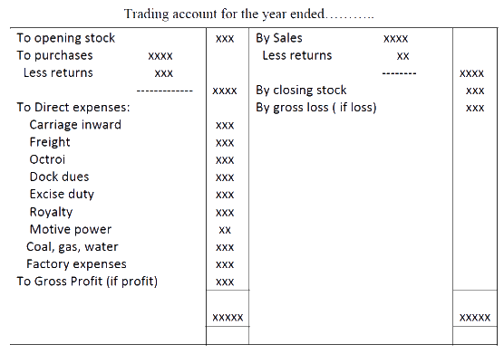

Format for Profit and Loss Account

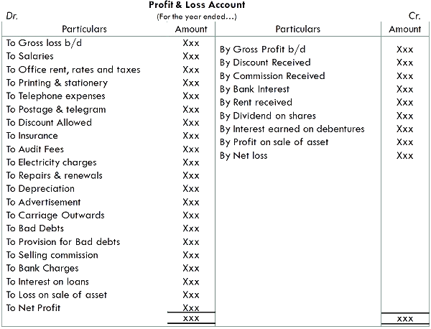

**Balance Sheet**

The Balance Sheet is a statement that shows the financial position of the business. It records the assets and liabilities of the business at the end of the accounting period after the preparation of trading and profit and loss accounts

## [*Not-for-Profit’ Organisations*](https://byjus.com/commerce/meaning-and-characteristics-of-not-for-profit-organisation/)design Balance Sheet for determining the financial position of the establishment. The preparation of the balance sheet is on the same pattern as of the trade entities. It depicts liabilities and assets as during the end of the year. Assets are depicted on the right-hand side, whereas the liabilities are depicted on the left-hand side.

## Balance Sheet Format:

The balance sheet of a company will look like the image given below.

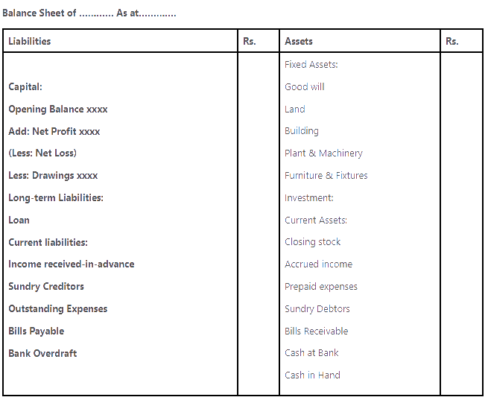

**Sources of Funds**

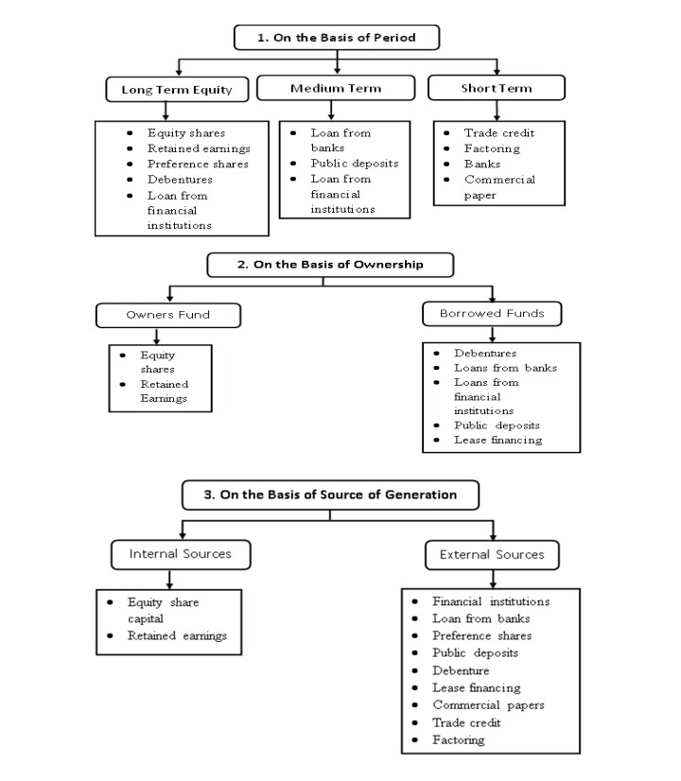

**Elements of Cost**

The elements of cost are those elements which constitute the cost of manufacture of a product. We can broadly divide these elements of cost into three categories. In a manufacturing organization, we convert raw materials into a finished product with the help of labor and other services. These services are Material, Labor and Expenses.

Again, we can bifurcate these elements of cost into two categories such as Direct Material and Indirect Material, Direct Labor and Indirect Labor, Direct Expenses and Indirect Expenses. We need to add all direct material, direct labor, and direct expenses to calculate the prime cost.

Likewise, we add all indirect material, indirect labor, and indirect expenses to calculate the overhead cost. Again, we can bifurcate the overheads into four categories. They are factory overhead, administrative overhead, selling overhead and distribution overhead.

#### ****1. Direct Material****

It represents the raw material or goods necessary to produce or manufacture a product. The cost of direct material varies according to the level of output. For example, Milk is the direct material of ghee.

#### ****2. Indirect Material****

It refers to the material which we require to produce a product but is not directly identifiable. It does not form a part of a finished product. For example, the use of nails to make a table. The cost of indirect material does not vary in the direct proportion of product.

#### ****3****. ****Direct Labour****

It refers to the amount which paid to the workers who are directly engaged in the production of goods. It varies directly with the level of output.

#### ****4. Indirect Labour****

It represents the amount paid to workers who are indirectly engaged in the production of goods. It does not vary directly with the level of output.

#### ****5. Direct Expenses****

It refers to the expenses that are specifically incurred by the enerprizes to produce a product. The production cannot take place without incurring these expenses. It varies directly with the level of production.

#### ****6. Indirect Expenses****

It represents the expenses that are incurred by the organization to produce a product. These expenses cannot be easily identified accurately. For example, Power expenses for the production of pens.

#### ****7. Overhead****

It refers to all indirect materials, indirect labor, or and indirect expenses.

#### ****8. Factory Overhead****

Factory overhead or Production Overhead or Works Overhead refers to the expenses which a firm incurs in the production area or within factory premises.

Indirect material, rent, rates and taxes of factory, canteen expenses etc. are example of factory overhead.

#### ****9. Administration Overhead****

Administrative or Office Overhead refers to the expenses which are incurred in connection with the general administration of the organizations.

Salary of administrative staff, postage, telegram and telephone, stationery etc.are examples of administration overhead.

#### ****10****. ****Selling Overhead****

All expenses that a firm incurs in connection with sales are selling overheads. Salary of sales department staff, travelers’ commission, advertisement etc. are example of selling overhead.

#### ****11****. ****Distribution Overhead****

It represents all expenses incurred in connection with the delivery or distribution of finished goods and services from the manufacturer to the consumer. Delivery van [expenses](https://www.toppr.com/guides/accountancy/financial-statements/prepaid-expenses-accrued-income-and-income-received-in-advanced/). loading and unloading, customs duty, the salary of deliverymen are examples of distribution overhead.

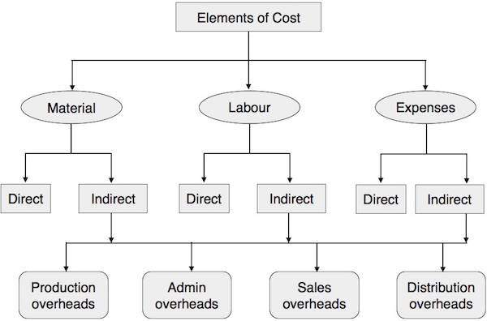

**Format of cost sheet**

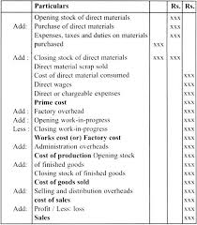

### [Depreciation](https://en.wikipedia.org/wiki/Depreciation)

In accounting terms, depreciation is defined as the reduction of recorded cost of a fixed asset in a systematic manner until the value of the asset becomes zero or negligible.

An example of fixed assets are buildings, furniture, office equipment, machinery etc.. A land is the only exception which cannot be depreciated as the value of land appreciates with time.

Depreciation allows a portion of the cost of a fixed asset to the revenue generated by the fixed asset. This is mandatory under the matching principle as revenues are recorded with their associated expenses in the accounting period when the asset is in use. This helps in getting a complete picture of the revenue generation transaction.

**An example of Depreciation**– If a delivery truck is purchased a company with a cost of Rs. 100,000 and the expected usage of the truck are 5 years, the business might depreciate the asset under depreciation expense as Rs. 20,000 every year for a period of 5 years.

### ****How to calculate depreciation ?****

### There three methods commonly used to calculate depreciation. They are:

1. Straight line method
2. Written down value method(WDV)

### 1) Straight-line depreciation method

This is the simplest method of all. It involves simple allocation of an even rate of depreciation every year over the useful life of the asset. The formula for straight line depreciation is:

Annual Depreciation expense = (Asset cost – Residual Value) / Useful life of the asset

**Example** – Suppose a manufacturing company purchases a machinery for Rs. 100,000 and the useful life of the machinery are 10 years and the residual value of the machinery is Rs. 20,000

**Annual Depreciation expense**= (100,000-20,000) / 10 = Rs. 8,000

**2) Written Down Value method**

Written Down Value method is a depreciation technique that applies a constant rate of depreciation to the net book value of assets each year thereby recognizing more depreciation expenses in the early years of the life of the asset and less depreciation in the later years of the life of the asset. In short, this method accelerates the recognition of depreciation expenses in a systematic way and helps businesses recognize more depreciation in the early years. It is also known as Diminishing Balance Method or Declining Balance Method

**The formula is as follows:**

**Written Down Value Method = (Cost of Asset – Salvage Value of the Asset) * Rate of Depreciation (in %)**

## ****Break-Even Analysis****

A break-even analysis is a financial tool which helps you to determine at what stage your company, or a new service or a product, will be profitable. In other words, it’s a financial calculation for determining the number of products or services a company should sell to cover its costs (particularly fixed costs). Break-even is a situation where you are neither making money nor losing money, but all your costs have been covered.  
Break-even analysis is useful in studying the relation between the variable cost, fixed cost and revenue. Generally, a company with low fixed costs will have a low break-even point of sale. For an example, a company has a fixed cost of Rs.0 (zero) will automatically have broken even upon the first sale of its product.

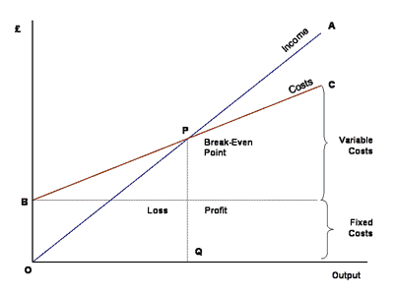

**Contribution per unit= Selling price per unit- Variable cost per unit**

**Contribution = Sales- Variable cost**

**P/V ratio ( Profit Volume)= (Contribution/Sales)*100**

**BEP sales in unit = Fixed cost/ Contribution per unit**

**BEP sales in Value= Fixed cost/ P/V ratio**

**When profit is given and desired sales has to find?**

**Desired Sales= (Fixed cost + Desired profit)/ P/V ratio**

**When sales is given and desired profit has to find?**

**Desired profit= (Fixed cost + Desired profit)/ contribution per unit**

**Margin of safety= Actual sales- BEP sales**

**Economic Appraisal of Projects**

**Economic appraisal** is a type of decision method applied to a project, programme or policy that takes into account a wide range of costs and benefits, denominated in monetary terms or for which a monetary equivalent can be estimated. Economic appraisal is a key tool for achieving value for money and satisfying requirements for decision accountability. It is a systematic process for examining alternative uses of resources, focusing on assessment of needs, objectives, options, costs, benefits, risks, funding, affordability and other factors relevant to decisions.

The main types of economic appraisal are:

* [Cost–benefit analysis](https://en.wikipedia.org/wiki/Cost%E2%80%93benefit_analysis)
* [Cost-effectiveness analysis](https://en.wikipedia.org/wiki/Cost-effectiveness_analysis)
* [Scoring and weighting](https://en.wikipedia.org/w/index.php?title=Scoring_and_weighting&action=edit&redlink=1)

Economic appraisal is a methodology designed to assist in defining problems and finding solutions that offer the best value for money (VFM). This is especially important in relation to public expenditure and is often used as a vehicle for planning and approval of public investment relating to policies, programmes and projects.

The principles of appraisal are applicable to all decisions, even those concerned with small expenditures. However, the scope of appraisal can also be very wide. Good economic appraisal leads to better decisions and VFM. It facilitates good project management and project evaluation. Appraisal is an essential part of good financial management, and it is vital to decision-making and accountability.